

**Enhancing foodborne disease surveillance across Australia**

**OzFoodNet Enteric Disease Surveillance Report 3rd Quarter 2021**

This report describes enteric disease surveillance and investigations carried out during the third quarter of 2021 (3Q21) by OzFoodNet Western Australia (WA) in conjunction with other WA Department of Health agencies and local governments.

The increase in notifications of *Vibrio parahaemolyticus* is due to the start of an oyster associated outbreak, that continued into the fourth quarter. The increase in rotavirus notifications is thought to be due to an introduction into WA of a new rotavirus strain. The decrease in other enteric notifications in 3Q21 continues to be likely due COVID-19 public health measures including travel restrictions and possible improvements in hand hygiene in the general community.

*Percentage change in the number of notifications in the current quarter compared to the historical five-year mean for the same quarter. Positive values indicate an increase when compared to the historical five-year mean of the same quarter. Negative values indicate a decrease when compared to the historical five-year mean of the same quarter. Percentage change should be interpreted with caution when the number of cases is small. **Haemolytic uraemic syndrome case was also notified with invasive *Streptococcus pneumoniae* infection

**

**Changes in enteric disease notifications (%)\***

**Most common enteric disease notifications in Quarter 3 2021**



**Refer to Appendix 1 for Enteric diseases by public health region:**

<https://ww2.health.wa.gov.au/-/media/Corp/Documents/Health-for/Infectious-disease/OZfoodnet/Word/WA-OzFoodnet-appendix1-2021-Q3.docx>

**Outbreaks in Quarter 3 2021**

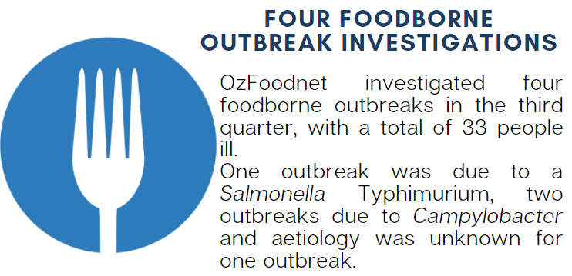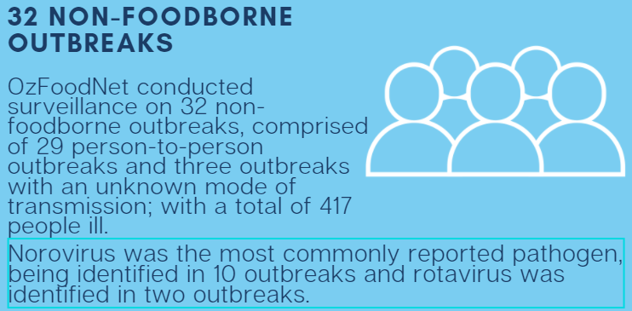

**Key trends from Quarter 3 2021**

***Salmonella* Typhimurium (STM)** **MLVA 03-17-09-12-523**

There has been a 64% decrease in all salmonellosisnotifications in 3Q21, with 142 notifications compared to the historical five-year average of 400 notifications. The most common serovar of *Salmonella* for 3Q21 was STM. There were 63 STM notifications in 3Q21, a 67% decrease compared to the historical five-year average of 190 notifications. The MLVA type 03-17-09-12-523 was the most common in 3Q21, as has been the case since its emergence in September 2016.

From September 2016 to September 2021 there were 1980 cases of 03-17-09-12-523 notified, including 13 cases in 3Q21. This MLVA type constituted 21% of STM notifications for the quarter. There was one point-source outbreak of MLVA 03-17-09-12-523 identified in this quarter comprising of 24 cases including eight confirmed cases. The majority of these (85%) cases resided in the Perth metropolitan area.



Figure: Notifications of *Salmonella* Typhimurium MLVA 03-17-09-12-523 in WA, September 2016 to September 2021

**Appendix 2** See link below for details of foodborne outbreaks investigated in Quarter 3, 2021:

<https://ww2.health.wa.gov.au/-/media/Corp/Documents/Health-for/Infectious-disease/OZfoodnet/Word/WA-OzFoodnet-appendix2-2021-Q3.docx>

**Yersiniosis**

There were seven notifications reported in 3Q21. All were culture positive and among Perth metropolitan residents. There were no point-source outbreaks identified in this reporting period.

**STEC**

Twelve of the 23 notifications were culture positive in 3Q21. Of these, most common serotypes were O157:H7 (n=3) and O128:H2 (n=3). There was a cluster investigation of five cases of STEC living in the Perth metropolitan region but whole genome sequencing of isolates found no common strains. No point-source outbreaks were identified in 3Q21. Some of the increase in comparison to the historical five-year average is likely due to PCR testing of all faecal specimens by one private laboratory since the fourth quarter of 2018.

**Rotavirus**

There were 192 notifications in 3Q21 compared to the historical five-year average of 92 cases. The majority (57%) of cases were aged less than five years. Most of the notifications were in the Perth metropolitan region (n=103) followed by the Kimberley region (n=62). The increase in notifications began in the Kimberley region and subsequently moved to public health regions further south. Initial typing results of rotavirus indicates that a new strain has emerged in the Kimberley region.