Foodborne disease surveillance and outbreak investigations in Western Australia 2018 annual report



**Enhancing foodborne disease surveillance across Australia**



OzFoodNet, Communicable Disease Control Directorate

**Acknowledgments**

Acknowledgement is given to the following people for their assistance with the activities described in this report: the staff from PathWest Laboratory Medicine WA; Mr John Coles and other staff from the Environmental Health Directorate of the Department of Health, Western Australia; Public Health Nurses from the metropolitan and regional Population Health Units; and Local Government Environmental Health Officers.

**Contributors/Editors**

Benjamin Witham, Stephania Tomlin, Nevada Pingault, Barry Combs, Darren Westphal and Niki Foster

Communicable Disease Control Directorate

Department of Health, Western Australia

PO Box 8172

Perth Business Centre

Western Australia 6849

Email: [OzfoodnetWA@health.wa.gov.au](mailto:OzfoodnetWA@health.wa.gov.au)

Telephone: (08) 9222 2152

Facsimile: (08) 9222 0254

Web:

OzFoodNet WA Health

<https://ww2.health.wa.gov.au/Articles/F_I/Infectious-disease-data/Enteric-infection-reports-and-publications-OzFoodNet>

OzFoodNet Department of Health and Ageing

[www.ozfoodnet.gov.au/](http://www.ozfoodnet.gov.au/)

**Disclaimer**:

Every endeavour has been made to ensure that the information provided in this document was accurate at the time of writing. However, infectious disease notification data are continuously updated and subject to change.

PUBLISHED BY

This publication has been produced by the **Department of Health, Western Australia**.

# Executive summary

This report is a summary of enteric disease surveillance activities and outbreak investigations in Western Australia (WA) in 2018.

Enteric disease causes a large burden of illness in the WA community. In WA, there are 16 enteric infections that are notifiable to the Department of Health. The Department of Health through OzFoodNet (OFN) and other agencies conducts surveillance and investigates outbreaks so that targeted interventions can be used to help prevent further transmission.

In 2018, there were 6388 notifications of enteric disease in WA, which was a rate of 231 per 100 000 population. The 2018 rate was 8% higher than the mean rate for the previous five years. The age group with the highest enteric disease rate was 0-4 years with 571 cases per 100 000 population. The rate of enteric disease for Aboriginal people was 1.7 fold higher than for non-Aboriginal people. Of the notified enteric infections with a known place of acquisition, 73% reported acquiring their infection in WA, 26% reported overseas travel and 1% reported interstate travel. Of enteric notifications reporting overseas travel, 61% had travelled to Indonesia.

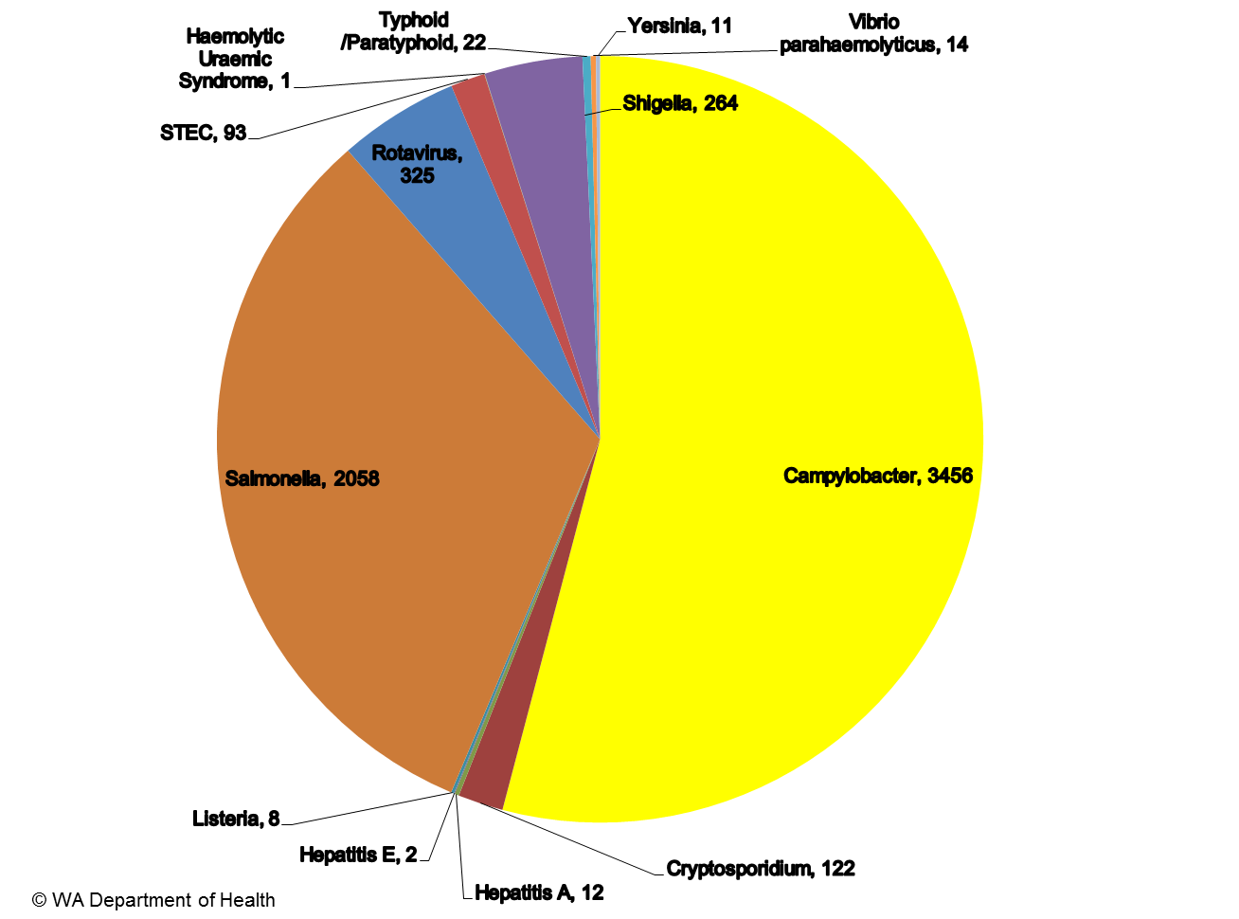

Figure A: Number of WA enteric disease notifications for 2018 by disease

Campylobacteriosiswas the most commonly notified enteric disease in 2018 (n=3456) followed by salmonellosis (n=2058) (Figure A);both had rates 12% higher than the previous five years. Shigellosis (n=264) and Shiga toxin-producing *E. coli* infection (n=93) also had higher rates compared to the previous five years.

**Foodborne and probable foodborne outbreaks**

In 2018, there were 37 outbreaks of foodborne or probable foodborne disease investigated in WA that caused at least 343 cases of illness. Of these 37 outbreaks, 31 were caused by *Salmonella* Typhimurium, two outbreaks were caused by *Salmonella* Bovismorbificans, and four were of unknown aetiology (Figure B).

Of the 37 outbreaks, there were 17 outbreaks where a food was implicated. Raw or undercooked egg dishes were the most commonly implicated food (n=12, 71%).

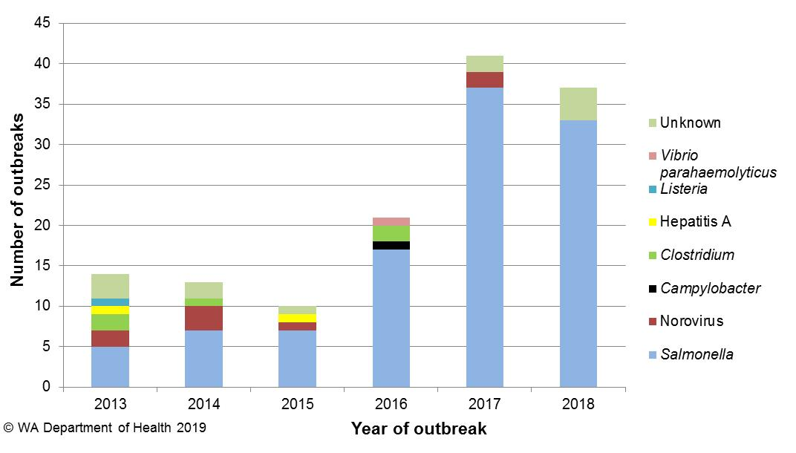

Figure B: Foodborne outbreaks investigated in WA by causative pathogen

**Non-foodborne enteric disease outbreaks**

Non-foodborne enteric disease outbreaks and outbreaks with an unknown mode of transmission are a major cause of illness, especially in institutions such as residential care facilities (RCFs). There were 104 non-foodborne outbreaks reported in 2018 which resulted in 2020 ill people, 32 hospitalisations and seven associated deaths. Most of these outbreaks were in RCFs and due to person-to-person transmission.

**Table of contents**

Executive summary 3

1. Introduction 7

2. Data sources and methods 9

2.1. Data sources 9

2.2. Data collection by Aboriginality 10

2.3. Regional boundaries 10

2.4. Calculation of rates 10

2.5. Definitions 10

3. Site activities including prevention measures during the year 11

3.1. Surveillance and investigation 11

3.2. Activities on enhancing laboratory and epidemiological surveillance 12

3.3. Activities to assist enteric disease policy development 12

3.4. Strengthening skills and capacity for enteric disease surveillance and investigation 13

3.5. Conference meetings and presentations 13

4. Incidence of specific enteric diseases 13

4.1. Campylobacteriosis 14

4.2. Salmonellosis 16

4.3. Rotavirus infection 21

4.4. Shigellosis 23

4.5. Cryptosporidiosis 26

4.6 Shiga toxin-producing *E. coli* infection 28

4.7 *Vibrio parahaemolyticus* infection 29

4.8 Hepatitis A infection 29

4.9 *Yersinia* infection 30

4.10 Typhoid and paratyphoid fever 30

4.11 Listeriosis 31

4.12 Haemolytic Uraemic Syndrome (HUS) 31

4.13 Hepatitis E infection 31

4.14 Cholera 31

4.15 Botulism 31

5 Gastrointestinal disease outbreaks and investigations 32

5.1 Foodborne and probable foodborne outbreaks 32

5.2 Outbreaks due to non-foodborne transmission or with an unknown mode of transmission 36

5.3 Cluster investigations 38

6. References 41

Appendix 1: Number of notifications, notification rate2 and ratio of current to historical mean by pathogen/condition, 2013 to 2018, WA 49

List of tables

Table 1 Number and proportion of the top 10 *Salmonella* serotypes notified in WA, 2018, with comparison to the 5-year average 20

Table 2 The 10 most common *S*. Typhimurium MLVA types reported in 2018 20

Table 3 Foodborne and probable foodborne outbreaks, 2018 34

Table 4 Outbreaks due to non-foodborne transmission or unknown mode of transmission in WA by setting and agent, 2018 38

Table 5 Cluster investigations in WA by month investigation started, setting and agent, 2018 40

List of figures

Figure 1 Number of notifications of campylobacteriosis by year and month of onset, WA, 2013 to 2018. 15

Figure 2 Age-specific notification rates for campylobacteriosis by sex, WA, 2018 15

Figure 3 Campylobacteriosis notification rates by Aboriginality, WA, 2013 to 2018. 16

Figure 4 Campylobacteriosis notification rates by region and Aboriginality, WA, 2018. 16

Figure 5 Number of notifications of salmonellosis by year and month of onset, WA, 2013 to 2018. 17

Figure 6 Age-specific notification rates for salmonellosis by sex, WA, 2018. 18

Figure 7 Salmonellosis notification rates by region and Aboriginality, WA, 2018 19

Figure 8 Salmonellosis notifications by place of acquisition, by year of onset, 2013 to 2018 21

Figure 9 Number of notifications of rotavirus infection by year and month of onset, WA, 2013 to 2018 21

Figure 10 Age-specific notification rates for rotavirus by sex, WA, 2018 22

Figure 11 Rotavirus notification rates by region and Aboriginality, WA, 2018 23

Figure 12 Number of notifications of shigellosis by year and month of onset, WA, 2013 to 2018 24

Figure 13 Age-specific notification rates for shigellosis by sex, WA, 2018 24

Figure 14 Shigellosis notification rates by region and Aboriginality, WA, 2018 25

Figure 15 The three most common *Shigella* types notified in 2018 26

Figure 16 Number of notifications of cryptosporidiosis by year and month of onset, WA, 2013 to 2018 27

Figure 17 Age-specific notification rates for cryptosporidiosis by sex, WA, 2018 28

Figure 18 Cryptosporidiosis notification rates by region and Aboriginality, WA, 2018 28

Figure 19 Place of acquisition for hepatitis A notifications, 2013 to 2018. 30

Figure 20 Number of gastroenteritis outbreaks designated as non-foodborne transmission (person-to-person, suspected environmental, unknown) in 2018 37

Figure 21 Notifications of *Salmonella* Typhimurium MLVA 03-17-09-12-523 in WA 39

# Introduction

It has been estimated that there are 5.4 million cases of foodborne illness in Australia each year and that the cost of this illness is $1.2 billion per year1. This is likely to be an underestimate of the true cost of enteric illness in Australia as not all enteric infections are caused by foodborne transmission. Other modes of transmission such as person-to-person, animal-to-person and waterborne transmission are also very important in enteric infection. Most enteric infections are preventable through interventions at the level of primary production, institution infection control, and food handling and hand hygiene at food businesses and in households.

This report describes Western Australian enteric disease surveillance and investigations carried out in 2018 by OzFoodNet WA (OFN) and other Western Australian government agencies. Most of the data presented in this report is derived from enteric disease notifications from doctors and laboratories received by the Department of Health, WA (WA Health) and are likely to underestimate the true incidence of disease. This data nevertheless remains the most important information on incidence of these infections for surveillance purposes in Western Australia (WA). In addition, norovirus, which is not notifiable, is the cause of a large burden of illness in residential care facilities (RCFs) and also in the general community.

OFN is part of the Communicable Disease Control Directorate (CDCD) of the WA Department of Health. OFN in WA is also part of a National OzFoodNet network funded by the Commonwealth Department of Health2. The mission of OzFoodNet is to enhance surveillance of foodborne illness in Australia and to conduct applied research into associated risk factors. The OFN site based in Perth is responsible for the whole of WA, which has a total population of approximately 2.7 million. Collaboration between States and Territories is facilitated by circulation of fortnightly jurisdictional enteric surveillance reports, monthly teleconferences, tri-annual face-to-face meetings and through the informal network. This network also includes communication and consultation with Food Standards Australia New Zealand, the Commonwealth Department of Health, the National Centre for Epidemiology and Population Health, the Communicable Diseases Network of Australia and the Public Health Laboratory Network.

The primary objectives of OzFoodNet nationally are to:

* estimate the incidence and cost of foodborne illness in Australia,
* investigate the epidemiology of foodborne diseases, by enhancing surveillance and conducting special studies on foodborne pathogens,
* collaborate nationally to coordinate investigations into foodborne disease outbreaks, particularly those that cross State, Territory and country borders,
* train people to investigate foodborne illness.

At a local level, OFN conducts surveillance of enteric infections to identify clusters and outbreaks of specific diseases and conducts epidemiological investigations to help determine the cause of outbreaks. OFN also conducts research into the risk factors for sporadic cases of enteric diseases and develops policies and guidelines related to enteric disease surveillance, investigation and control. OFN regularly liaises with staff from the Population Health Units (PHUs), the Environmental Health Directorate of WA Health (EHD); and the Environmental, Diagnostic and Surveillance laboratories at PathWest Laboratory Medicine WA (PathWest).

CDCD maintains and coordinates the WA notifiable disease surveillance system and provides specialist clinical, public health and epidemiological training and advice to PHUs. The WA notifiable diseases surveillance system relies on the mandatory reporting by doctors and laboratories of notifiable diseases and syndromes, 16 of which are enteric.

PHUs are responsible for public health activities, which includes communicable disease control, in their WA administrative health regions. There are eight PHUs in WA that are involved with communicable disease surveillance: Metro, Kimberley, Pilbara, Midwest, Wheatbelt, Goldfields, South West, and Great Southern. The PHUs monitor RCF gastroenteritis outbreaks and provide infection control advice. The PHUs also conduct follow up of single cases of important enteric diseases including typhoid, paratyphoid, hepatitis A and E, cholera and *Shigella dysenteriae*. OFN will also assist with the investigation of these enteric diseases if there is a cluster and/or they are locally acquired, and will investigate RCF outbreaks if the outbreak is due to probable foodborne transmission.

The EHD liaises with Local Government (LG) Environmental Health Officers (EHOs) during the investigation of food businesses, and coordinates food business investigations when multiple LGs are involved.

The Environmental, Diagnostic and Surveillance laboratories at PathWest provide public health laboratory services for the surveillance and investigation of enteric disease.

# Data sources and methods

### **Data sources**

Data on WA cases of notifiable enteric diseases were obtained from the WA notifiable infectious disease database (WANIDD). The notifications contained in WANIDD are received from medical practitioners and pathology laboratories under the provisions of the Public Health Act 2016 and subsequent amendments, and are retained in WANIDD if WA (for diseases not nationally notifiable)3 or national case definitions are met4.

Notifiable enteric diseases included in this report are campylobacteriosis, salmonellosis, rotavirus infection, cryptosporidiosis, shigellosis, hepatitis A infection, listeriosis, typhoid fever, shiga toxin-producing *E. coli* (STEC) infection, *Vibrio parahaemolyticus* infection, yersiniosis, hepatitis E infection, paratyphoid fever, cholera, haemolytic uraemic syndrome (HUS) and botulism. In April 2019, data for these diseases were extracted from WANIDD by optimal date of onset (ODOO) for the time period 01/01/2013 to 31/12/2018, and exported to Microsoft® Excel 2010. The ODOO is a composite of the ‘true’ date of onset provided by the notifying doctor or obtained during case follow-up, the date of specimen collection for laboratory notified cases, and when neither of these dates is available, the date of notification by the doctor or laboratory, or the date of receipt of notification, whichever is earliest.

Notification data extracted for this report may have been revised since the time of extraction. Subsequent minor changes to the data would not substantially affect the overall trends and patterns.

Information on *Salmonella* serotypes and *Shigella* species was obtained from PathWest, the reference laboratory for WA. Other specialised diagnostic data were obtained from the Microbiological Diagnostic Unit, University of Melbourne; the Australian *Salmonella* Reference Laboratory, Institute of Medical and Veterinary Science (Adelaide), Institute of Clinical Pathology and Medical Research (Sydney) and Queensland Health Forensic and Scientific Services. Pulsed field gel electrophoresis (PFGE) typing and multi-locus variable number tandem repeat analysis (MLVA) were carried out at PathWest.

Information on RCF outbreaks was collected by PHU staff who forward collated epidemiological and laboratory data to OFN.

### **Data collection by Aboriginality**

For the purposes of this report, the term ‘Aboriginal’ is used in preference to ‘Aboriginal and Torres Strait Islander’ to recognise that Aboriginal people are the original inhabitants of WA.

In WA, there is considerable mobility of Aboriginal people, both within WA and across the Northern Territory and South Australia borders, which means that some Aboriginal people will be patients of more than one health service. Due to the small size of the Aboriginal population in WA (3.6% of the total population in 2018) and the large number of cases reported in Aboriginal people, inaccuracies in the population estimates of Aboriginal people can have a disproportionate impact on calculated rates. In the preparation of this report, these factors are acknowledged as limitations.

### **Regional boundaries**

Notification data are broken down by regions that are based on PHU boundaries, reflecting WA Health administrative regions: Metropolitan Perth (METRO), South West (STHW), Great Southern (GSTH), Goldfields (GOLD), Central/Wheatbelt (CENT), Midwest (MIDW), Pilbara (PILB) and Kimberley (KIMB). PHU contact numbers and details are outlined at the website location in reference 5.

### **Calculation of rates**

WA’s estimated resident population figures used for calculation of rates were obtained from Rates Calculator version 9.5.5 (Epidemiology Branch, WA Department of Health). The Rates Calculator provides population estimates by age, sex, Aboriginality, year and area of residence, and is based on population figures derived from the 2011 census. The projected estimated population for WA in 2018 was 2 762 238 persons. Rates calculated for this report have not been adjusted for age.

### **Definitions**

**Foodborne outbreak** is an incident where two or more persons experience a similar illness after consuming a common food or meal and epidemiological analyses and/or microbiological evidence (including food and/or environmental) implicates the meal or food as the source of illness.

**Probable foodborne outbreak** is an incident where two or more persons experience a similar illness after consuming a common food or meal and a specific meal or food is suspected, but another mode of transmission cannot be ruled out.

**Person-to-person outbreak** is an incident where two or more persons experience a similar illness after exposure to an infected person.

**Unknown outbreak transmission** is an incident where two or more persons experience a similar illness but the mode of transmission is unable to be determined.

An implicated dish in a *Salmonella* outbreak is described as an **egg dish** if

* *Salmonella* is isolated from eggs (from the implicated premises) or the implicated dish containing eggs (microbiological evidence) OR
* There is analytical evidence that a dish containing eggs was associated with illness OR
* In the absence of microbiological or analytical evidence, an implicated dish is described as an egg dish if it contains raw or undercooked eggs and most cases report eating the dish in the absence of other high risk foods eaten in common.

# Site activities including prevention measures during the year

During 2018 the following activities and prevention measures were conducted by OFN.

### **Surveillance and investigation**

* Ongoing surveillance of infectious enteric disease in WA.
* Investigation of 37 local foodborne or probable foodborne outbreaks and 24 clusters.
* Investigation of eight *Listeria* *monocytogenes* cases.
* Surveillance of nine paratyphoid and 13 typhoid cases.
* Investigation of *S.* Enteritidis cases with unknown travel history and interviews of eight locally acquired cases with a hypothesis generating questionnaire to identify risk factors for the cause of illness.
* Investigation of 91 person-to-person gastroenteritis outbreaks, including 56 that occurred in RCFs and 24 in child care centres.
* Investigation of 11 gastroenteritis outbreaks with unknown mode of transmission, nine of which occurred at RCFs
* Investigation of two environmental outbreaks caused by norovirus.
* Investigation of 93 cases of STEC to identify risk factors for the cause of illness.

### **Activities on enhancing laboratory and epidemiological surveillance**

* Participation in ongoing quarterly meetings with PathWest and EHD staff.
* Participation in six monthly meeting with EHD and CDCD (including OFN) from WA Health, and the Department of Primary Industries and Regional Development to discuss zoonotic diseases in WA.
* Provision of enteric disease data, interpretation and advice upon request to LG EHOs, laboratory and PHU staff.
* Participation in monthly national OzFoodNet teleconferences.
* Monitoring of culture-independent nucleic acid amplification diagnostic testing in private laboratories and impact on notification rates.
  + Including maintaining enhanced data set for STEC notifications due to the increase in notifications from laboratories conducting polymerase chain reaction (PCR) based tests.
* Addition of illness and exposure data for WA *Listeria monocytogenes* and hepatitis A cases to national enhanced data sets.
* Provision of information on diarrhoea-only outbreaks of unknown aetiology to PathWest for use in development and validation of a viral PCR panel.
* Participation in cryptosporidiosis project with Murdoch University on the molecular typing of *Cryptosporidium* isolates from public swimming pools and human cases.

### **Activities to assist enteric disease policy development**

* OFN epidemiologists were members of OzFoodNet and other national working groups on:
  + Outbreak register
  + Foodborne disease tool kit
  + STEC enhanced surveillance
  + Culture-independent diagnostic testing
  + *Shigella* Series of National Guidelines (SoNGs)
  + Enhanced hepatitis A surveillance project
  + National Policy for reporting and managing communicable disease events on cruise ships
  + Antimicrobial resistance in *Salmonella* isolates from egg laying environments.
* Participation in the Foodborne Illness Reduction Strategy Across-Government Advisory Group and implementation plan focus groups.

### **Strengthening skills and capacity for enteric disease surveillance and investigation**

* Together with EHD, conducted foodborne outbreak investigation training for EHOs and public health nurses in metropolitan Perth in February.
* Lectured and conducted an outbreak scenario workshop on foodborne pathogens to Masters level students at University of Western Australia in September.
* Presented an enteric diseases update at the Public Health Nurses seminar in November.
* Presented a talk on ‘Gastroenteritis outbreak management for aged care facilities’ at the Disease Control Update Day for South West residential aged care facility and infection control staff in Bunbury in October.

### **Conference meetings and presentations**

* Attended the national OFN face-to-face (F2F) meetings in Sydney (March), Alice Springs (June) and Canberra (November).
* Presented a talk on ‘WGS of epidemic STM in WA’ at the OFN F2F meeting in Sydney
* Presented a talk on ‘Enteric Disease in WA – have we closed the gap between Aboriginal and non-Aboriginal people?’ at the OFN F2F meeting in Alice Springs.
* Contributed data for a DoH talk on *Salmonella* as part of the *Salmonella* workshop for regulators in Perth in October.
* Presented a talk on ‘Outbreak investigation from an epidemiological perspective’at the Avian Industry Consultative Group Meeting in Perth in October.
* Presentated a talk on “Epidemic *Salmonella* Typhimurium in WA” at the 43rd National Conference of Environmental Health Australia in Perth in November.

# Incidence of specific enteric diseases

In 2018, there were 6388 notifications of enteric disease in WA, which was a rate of 231 per 100 000 population. This rate was 8% higher than the mean rate for the previous five years of 214 per 100 000 population. The overall rate was heavily influenced by *Campylobacter* and *Salmonella* infections which comprised 54% and 32% of notifications, respectively. The age group with the highest enteric disease rate was 0-4 years with 571 cases per 100 000 population, which is 2.5 times the overall rate for WA. In 2018, Aboriginal people had a rate of 352 cases per 100 000 population which was 1.7 fold higher than for non-Aboriginal people (214 cases per 100 000 population). The age group with the highest rate among Aboriginal people was 0-4 years with a rate of 1498 cases per 100 000 population, compared to a 0-4 year age group rate for non-Aboriginal people of 481 cases per 100 000 population. The region with the highest rate was the KIMB region with 615 cases per 100 000 population. The GSTH and PILB regions had the next highest rates (261 cases per 100 000 population and 254 cases per 100 000 population, respectively). The KIMB region had the highest rates for Aboriginal people (842 per 100 000 population) and non-Aboriginal people (392 per 100 000 population). Of the people notified with enteric infections with a known place of acquisition, 73% reported acquiring their infection in WA, 26% reported overseas travel and 1% reported interstate travel. Most (61%) people with enteric notifications who reported overseas travel had travelled to Indonesia.

### Campylobacteriosis

Campylobacteriosis was the most commonly notified enteric infection in 2018 with 3456 notifications and a rate of 125 per 100 000 population. This notification rate was the same as the 2017 rate (125 per 100 000 population), and 12% higher than the previous five year average (Appendix 1 and Figure 1). In 2018, notifications decreased from February to April and then increased, peaking in August and October to November. In 2018, the campylobacteriosis notification rate for males was higher than for females (136 and 114 per 100 000 population, respectively). The highest rates were in young children 0-4 years (177 per 100 000 population) followed by older adults 75- 79 years (173 per 100 000) and 70-74 years (165 per 100 000 population) (Figure 2). The lowest rates were in the age groups 5-9 years (76 per 100 000 population) and 10-14 years (83 per 100 000 population).

For the last six years the notification rate for non-Aboriginal people has been consistently higher than for Aboriginal people and for 2018, the rate for non-Aboriginal people was 131% higher (119 and 52 per 100 000 population, respectively) (Figure 3). The 2018 notification rate for campylobacteriosis was highest in the GSTH region (154 cases per 100 000 population). The region with the lowest rate was the PILB (82 per 100 000 population) (Figure 4). Of those campylobacteriosis cases with known place of acquisition, most (71%) people acquired their illness in WA with 28% of people acquiring their illness overseas. Indonesia was the most common (68%) country of acquisition.

At least some of the increase in campylobacteriosis notifications is likely to be due to the use of PCR testing of faecal specimens by one large private pathology laboratory since 2014, and other private laboratories since 2016, which has greater sensitivity than culture techniques.

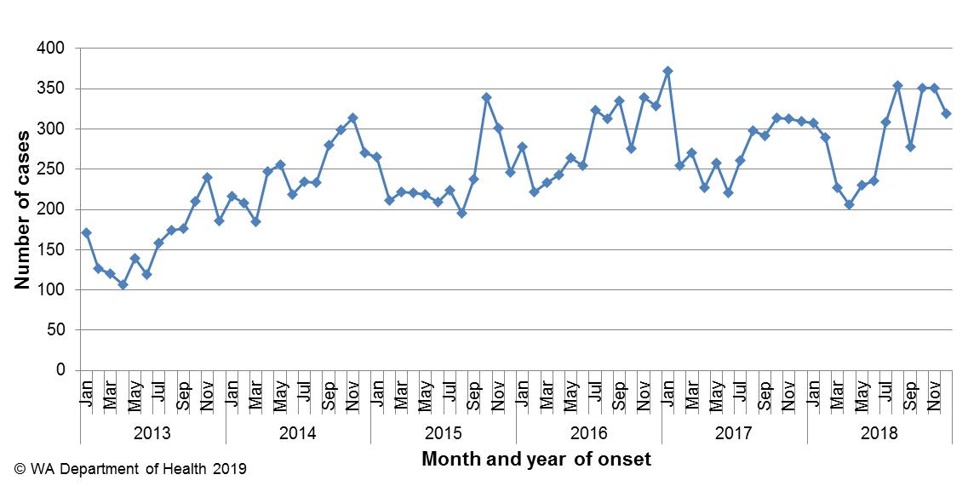

Figure 1 Number of notifications of campylobacteriosis by year and month of onset, WA, 2013 to 2018.

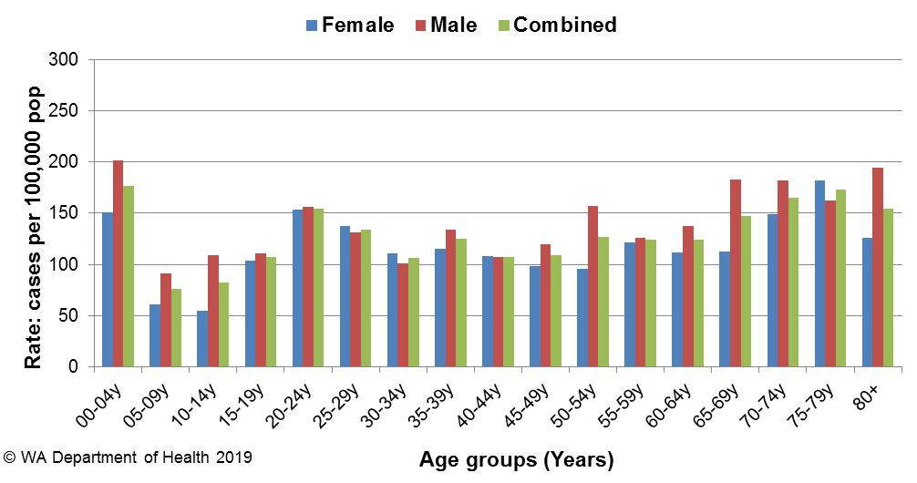

Figure 2 Age-specific notification rates for campylobacteriosis by sex, WA, 2018

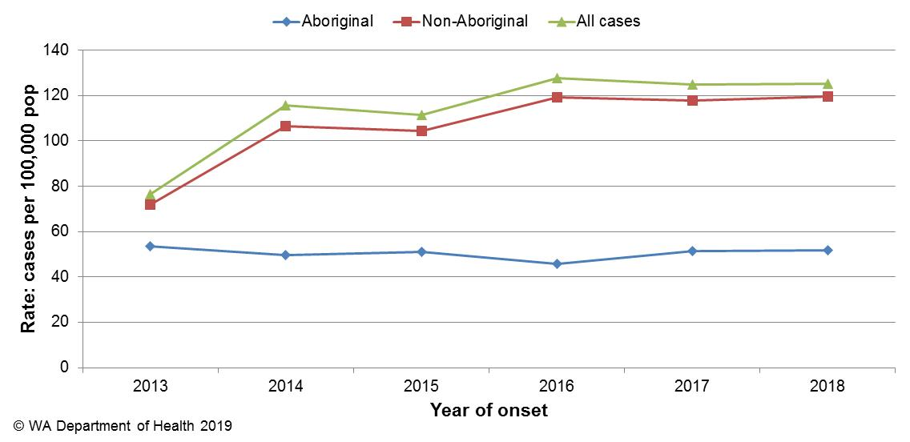

Figure 3 Campylobacteriosis notification rates by Aboriginality, WA, 2013 to 2018.

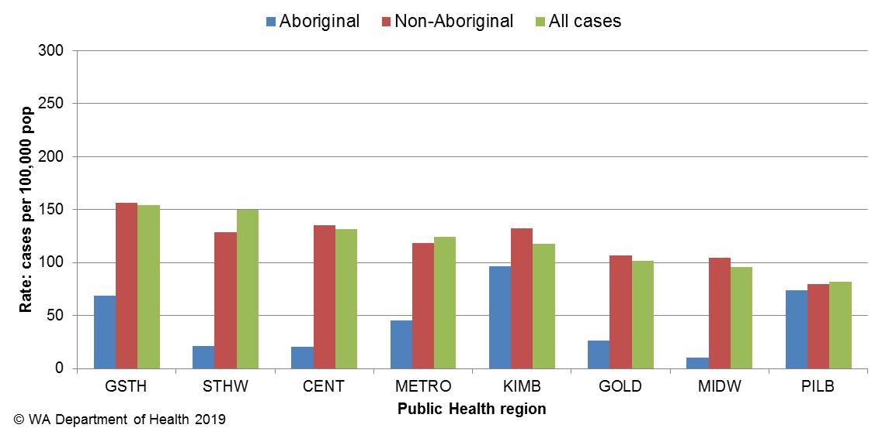

Figure 4 Campylobacteriosis notification rates by region and Aboriginality, WA, 2018.

### Salmonellosis

Salmonellosis, which is an infection due to *Salmonella,* was the second most commonly notified enteric infection in WA in 2018, with 2058 cases (Appendix 1). The salmonellosis notification rate for 2018 was 75 cases per 100 000 population which is the second highest salmonellosis rate ever reported in WA (2017 being the highest at 95 per 100 000 population) and the second highest rate for 2018 among Australian jurisdictions ([NNDSS data](http://www9.health.gov.au/cda/source/rpt_4_sel.cfm)). The WA rate was 12% higher than the previous five year average (67 cases per 100 000 population). Historically, salmonellosis notifications are highest in the summer months. Unusually, the peak for salmonellosis in 2018 was noted in May, which was attributed to three outbreaks investigated in that month (Figure 5).

The notification rate for females was 12% higher than for males (79 and 70 per 100 000 population, respectively). As in previous years, the 0-4 year age group had the highest notification rate (235 per 100 000 population) (Figure 6). The age group 60-64 years, had the next highest notification rate (75 per 100 000 population).

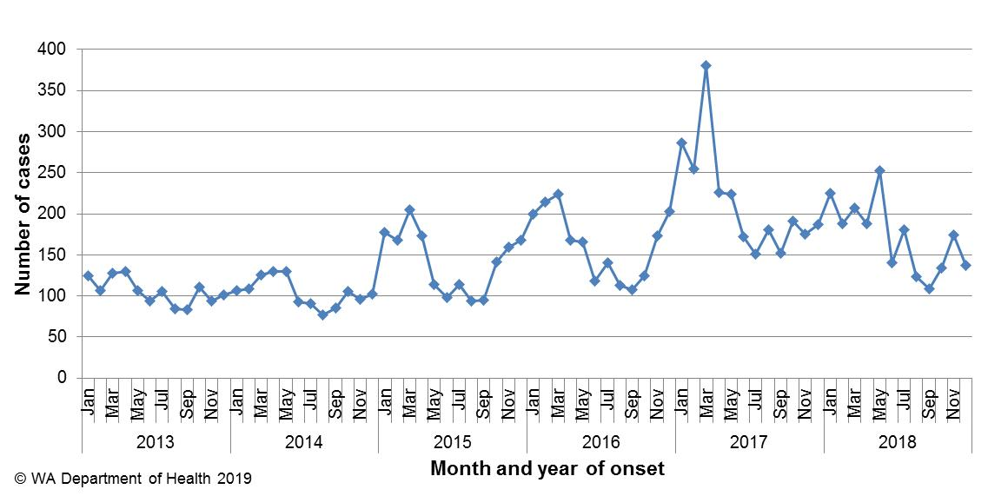

Figure 5 Number of notifications of salmonellosis by year and month of onset, WA, 2013 to 2018.

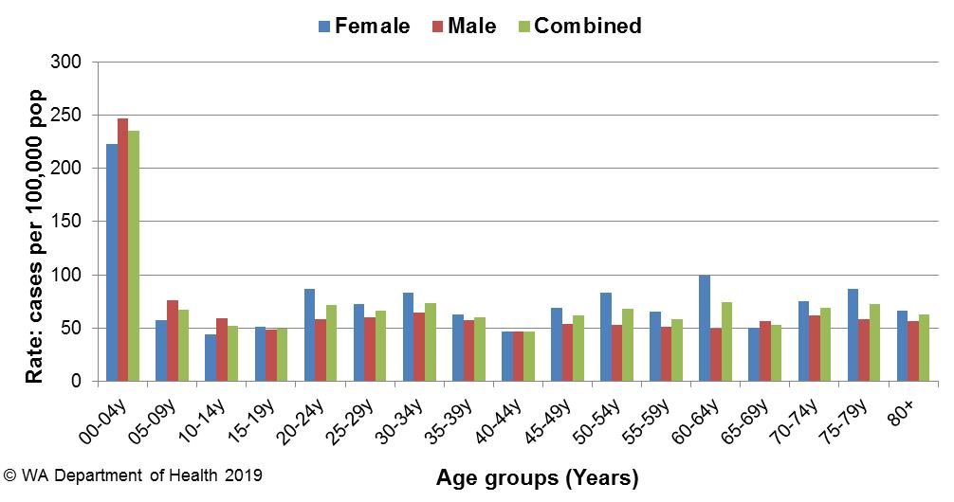

Figure 6 Age-specific notification rates for salmonellosis by sex, WA, 2018.

The overall salmonellosis notification rate for Aboriginal people was 109 cases per 100 000 population, which was 1.54 times the notification rate for non-Aboriginal people, of 70 cases per 100 000 population.

The KIMB region had the highest notification rate in 2018 (213 per 100 000 population) which was 3.7 times the rate for the CENT region, which had the lowest notification rate, of 58 cases per 100 000 population. In the KIMB region, rates were higher for both Aboriginal and non-Aboriginal people when compared with other regions (Figure 7). These notifications in the KIMB region included a variety of serotypes and did not cluster in time or location. Of those salmonellosis cases with known place of acquisition (1583/2058, 77%), most (77%) people acquired their illness in WA with 22% of people acquiring their illness overseas (Figure 8). Indonesia was the most common (60%) country of acquisition.

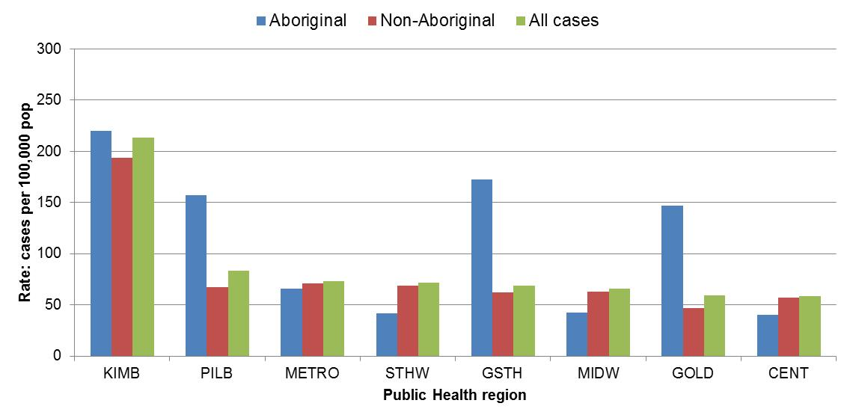

Figure 7 Salmonellosis notification rates by region and Aboriginality, WA, 2018

The most commonly notified *Salmonella* serotype in WA in 2018 was *S.* Typhimurium (STM), with 1051 notifications (Table 1), which was 1.46 fold higher than the mean of the previous five years. STM is further typed using MLVA and there were 202 MLVA types identified in 2018. Of these, the top 10 types contributed 61% (n= 640) of the total STM notifications and the most common MLVA type (03-17-09-12-523) contributed 40% of all STM notifications (Table 2). MLVA type 03-17-09-12-523 was also the *Salmonella* type that caused 17 of the 33 *Salmonella* outbreaks investigated in 2018. The next most common MLVA types were 03-17-10-12-523 (n=41), which is closely related to the most common MLVA pattern, and 03-10-17-11-496 (n=34), which caused one and zero outbreaks, respectively.

The second most commonly notified serotype was *S*. Enteritidis with 175 notifications, which was 19% below the mean of the previous five years (Table 1). In 2018, 93% (162/175) of cases with *S*. Enteritidis infection travelled overseas during their incubation period and of these cases, 70% (n=113) had travelled to Indonesia. There were eight (5%) cases of *S*. Enteritidis that appeared to be locally acquired, but interviews of cases did not identify a common source.

Notifications of *S.* Kentucky and *S.* Hvittingfoss were more than double the averages of the previous five years (Table 1). The number of *S.* Kentucky notifications was high from January to February and May to June, and mostly affected residents in the metropolitan area. *S.* Hvittingfoss was investigated in March when the number of notifications totalled 12 for February and March combined. Details of both cluster investigation were provided in the OzFoodNet 2018 first quarter report. No hypothesis for the cause of illness could be established in either cluster. The increase in *Salmonella* species (where a species was not identified) was likely to be due to the introduction of PCR testing by some WA laboratories. Some specimens are PCR-positive for *Salmonella* but culture-negative. A culture-positive result is required for the serotype to be determined.

Table 1 Number and proportion of the top 10 *Salmonella* serotypes notified in WA, 2018, with comparison to the 5-year average

*Percentage of total *Salmonella* cases notified in 2018.

‡Ratio of the number of reported cases in 2018 compared to the five year mean of 2013-2017.

Table 2 The 10 most common *S*. Typhimurium MLVA types reported in 2018



*Sporadic cases are not identified as part of a source outbreak

^Outbreak included 2 notified cases of 03-13-11-10-523 and 2 notified cases of 03-13-13-10-523

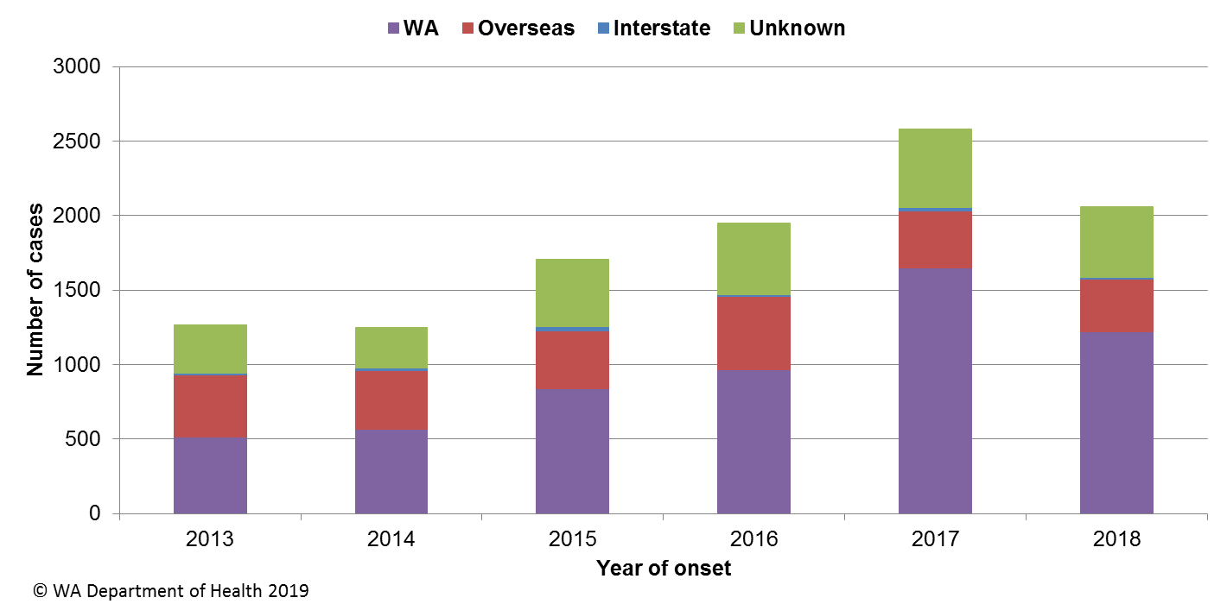

Figure 8 Salmonellosis notifications by place of acquisition, by year of onset, 2013 to 2018

### Rotavirus infection

There were 325 cases of rotavirus infection in WA in 2018 (11.8 per 100 000 population), making rotavirus the third most commonly notified enteric infection. The notification rate in 2018 was 25% lower than the previous five year average of 15.8 cases per 100 000 population (Appendix 1). Historically, rotavirus notifications typically peak in the winter months (Figure 9). While this seasonal pattern was observed in 2018, unusually, the highest number of notifications was seen in November.

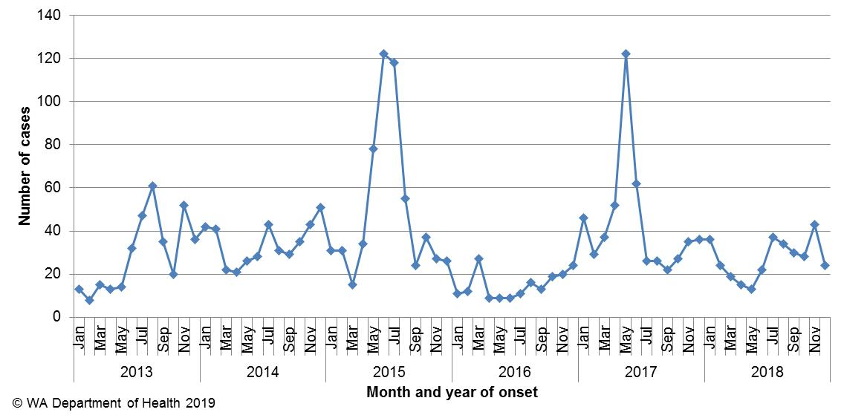

Figure 9 Number of notifications of rotavirus infection by year and month of onset, WA, 2013 to 2018

As in previous years, the age group with the highest rotavirus notification rate in 2018 was the 0-4 years group (97 cases per 100 000 population), followed by the 80+ year age group (11 cases per 100 000 population) (Figure 10). The overall notification rate was similar for females and males (12 and 11 per 100 000 population, respectively).

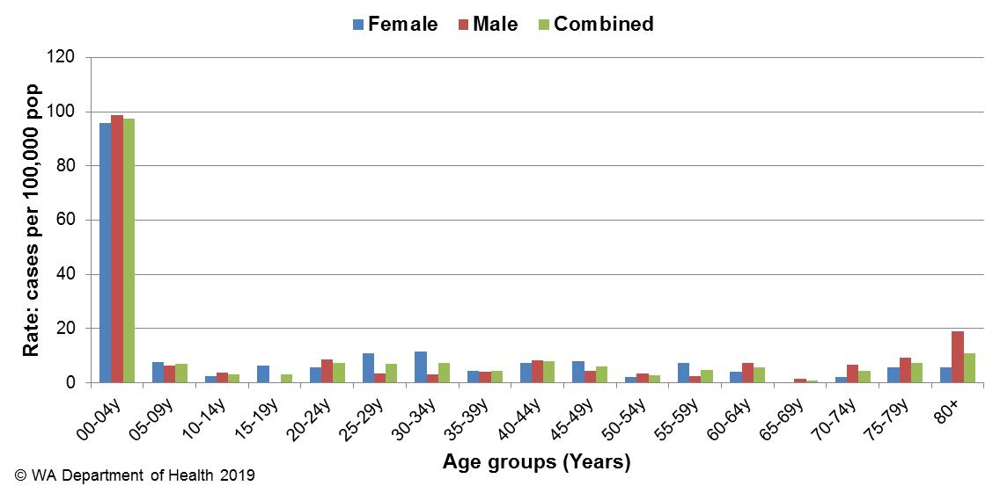

Figure 10 Age-specific notification rates for rotavirus by sex, WA, 2018

The regions with the highest rotavirus notification rates in 2018 were the KIMB, PILB and GOLD regions (68, 29 and 20 cases per 100 000 population, respectively) (Figure 11). Overall, notification rates were 4.0 times higher for Aboriginal than for non-Aboriginal people (39 and 10 per 100 000 population, respectively). Of those rotavirus cases with known place of acquisition, most (84%) people acquired their illness in WA with 12% of people acquiring their illness overseas. There was one person-to-person outbreak due to rotavirus and adenovirus in a RCF (Table 4).

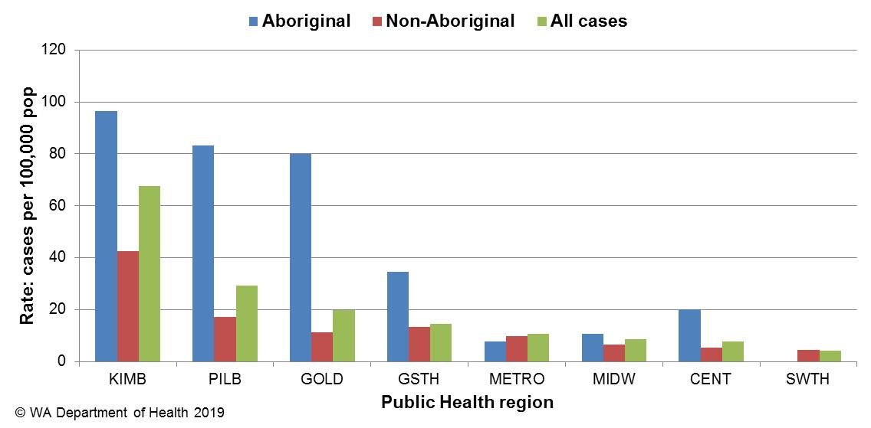

Figure 11 Rotavirus notification rates by region and Aboriginality, WA, 2018

### Shigellosis

As of 1 July 2018 the national *Shigella* case definition changed to include notifications that are PCR positive cases as probable cases and culture positive cases as confirmed cases. In 2018 there were 58 PCR probable shigellosis notifications (2 cases per 100 000), these were all notified as *Shigella* species. Of the 58 probable notifications, 93% (n=54) were for Metropolitan residents, and of those, 50% (n=27) were acquired overseas.

There were 206 cases of culture-positive shigellosis notified in 2018, with a notification rate of 7.5 per 100 000 population, which is 2 fold higher than the previous five year average (Appendix 1). The number of notifications was highest in January 2018 (Figure 12).

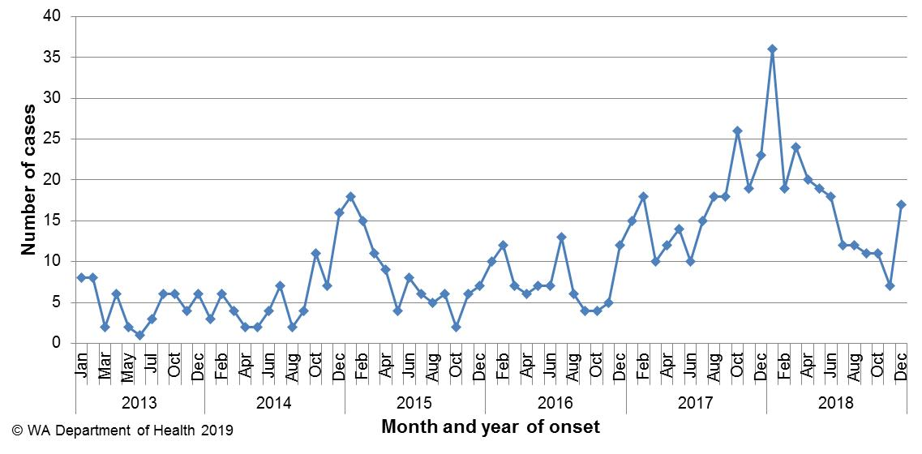

Figure 12 Number of notifications of shigellosis by year and month of onset, WA, 2013 to 2018

The shigellosis notification rate was 34% higher in females compared to males in 2018 (8.6 and 6.4 per 100 000 population, respectively). The 0-4 years age group had the highest rate of notification with 26 cases per 100 000 population (Figure 13). The PHU with the highest notification rate was the KIMB (166 cases per 100 000 population) (Figure 14).

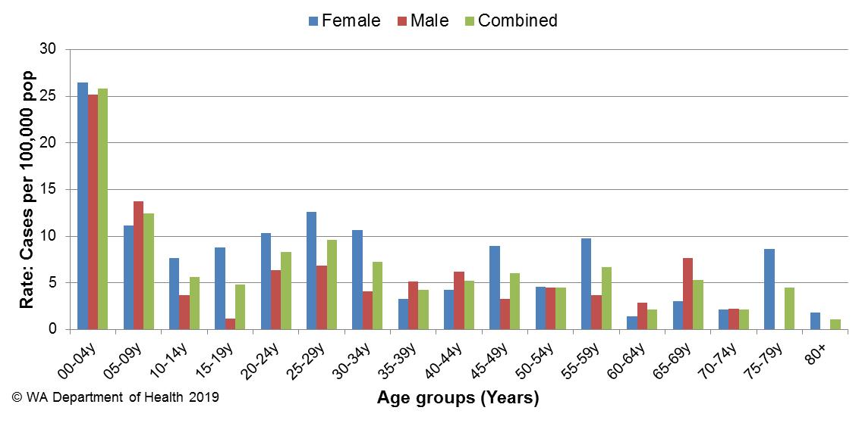

Figure 13 Age-specific notification rates for shigellosis by sex, WA, 2018

In 2018, the notification rate was 44 times higher for the Aboriginal population as compared to the non-Aboriginal population (129 and 3 per 100 000 population, respectively).

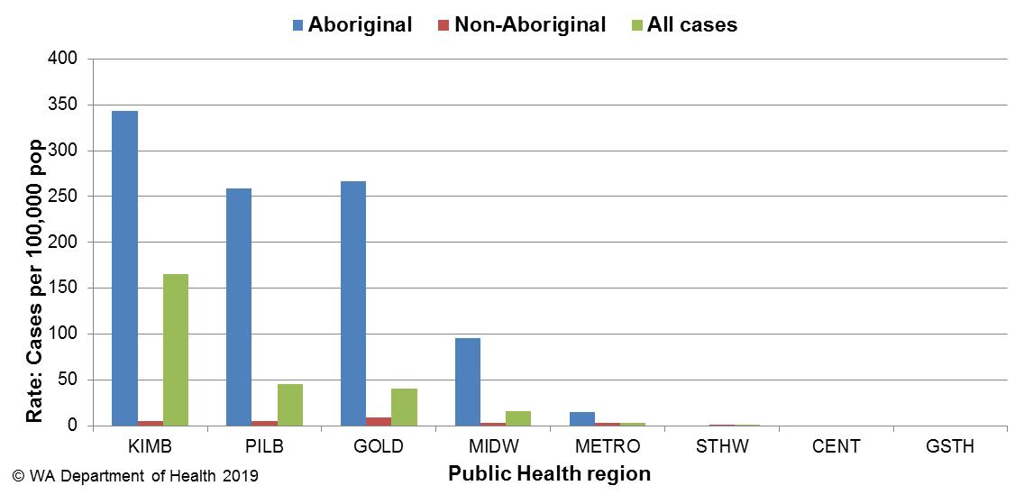

Figure 14 Shigellosis notification rates by region and Aboriginality, WA, 2018

The predominant subtypes of *Shigella* notified in 2018 were *S. flexneri* 2b (n=132) which was highest in January then decreased and peaked again in April, *S. sonnei* biotype G (n=33) which peaked in February and then decreased, and *S. flexneri* 2a (n=12) which had small numbers of notifications reported throughout the year (Figure 15). *S. flexneri* 2b notifications were 500% higher than the five year average of 22 notifications. Of the notifications with known travel history, 98% *S. flexneri* 2b were locally acquired and 89% were in Aboriginal people. The PHU with the highest notification rate was KIMB (166 cases per 100 000 population) followed by PILB and GOLD (45 cases per 100 000 population and 41 cases per 100 000 population, respectively). As a response to the high S. flexneri 2b rates in the KIMB a Public Health Alert was issues in June 2018 to health care providers in the region on symptoms to be aware of, treatment and health promotion to reduce the spread. A cluster investigation was carried out in October 2018 in the GOLD PHU region after an increase in notifications. The Northern Territory and South Australia also noted increases in this serotype. *S. flexneri* 2a and *S. sonnei* biotype G notifications were 200% and 42% higher than the five year average, respectively. For *S. flexneri* 2a of those with travel history, 57% were locally acquired and 45% were in Aboriginal people; of the 62% of *S. sonnei* biotype G with travel history, 44% cases had travelled overseas and all cases were non-Aboriginal people. *S. sonnei* biotype G was 20% higher in males (n=18) than females (n=15).

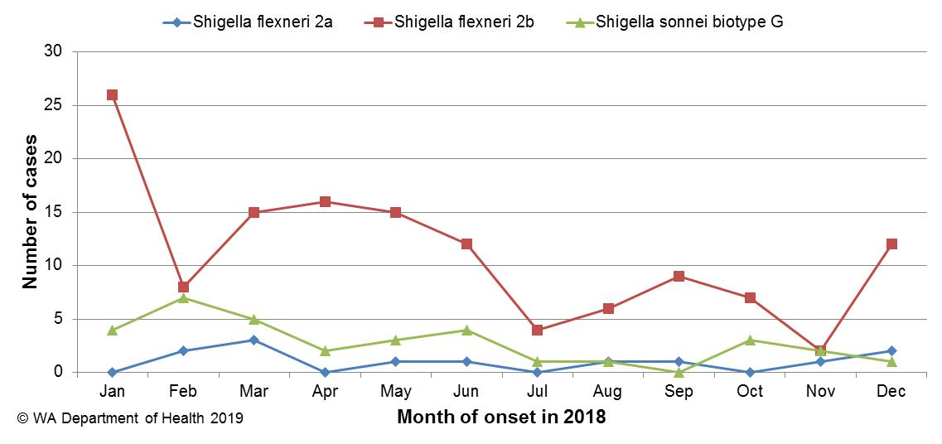

Figure 15 The three most common *Shigella* types notified in 2018

### Cryptosporidiosis

There were 122 cryptosporidiosis cases notified in 2018, which was the fifth most common notifiable enteric disease. The notification rate (4.4 cases per 100 000 population) was 64% lower than the mean of the previous five years (12.1 cases per 100 000 population) (Appendix 1). In each of the years from 2013 to 2018, the number of cryptosporidiosis notifications was higher in the late summer through to autumn (Figure 16). Despite the similar pattern, the number of cryptosporidiosis notifications in 2018 was the lowest in the last six years.

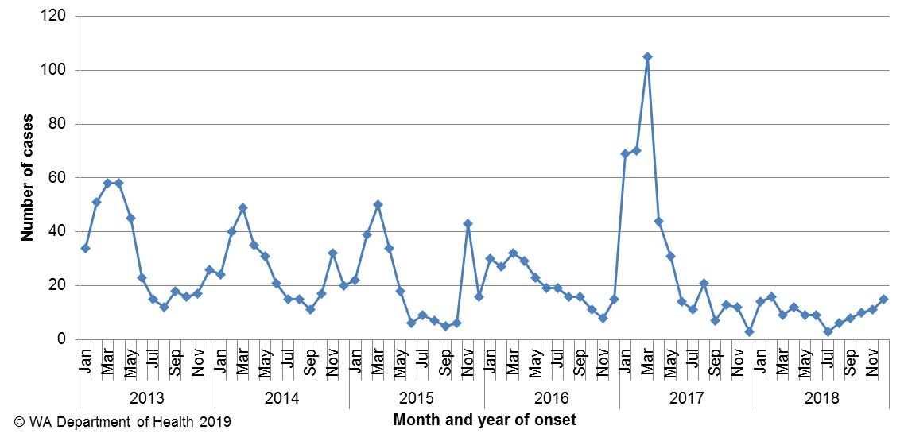

Figure 16 Number of notifications of cryptosporidiosis by year and month of onset, WA, 2013 to 2018

The cryptosporidiosis notification rate in females was 47% higher than males in 2018 (5.3 and 3.6 per 100 000 population, respectively). The 0-4 years age group had the highest notification rate (20 per 100 000 population), and accounted for 31% of all cryptosporidiosis notifications (Figure 17). The overall notification rate for the Aboriginal population was 6 times the rate for the non-Aboriginal population (21 and 4 cases per 100 000 population, respectively). The KIMB region had the highest notification rate (48 cases per 100 000 population) and the GOLD region had no notifications in 2018 (Figure 18). Of those cryptosporidiosis cases with known place of acquisition, most (72%) people acquired their illness in WA, with 27% of people acquiring their illness overseas and 1% of people acquiring their illness interstate.

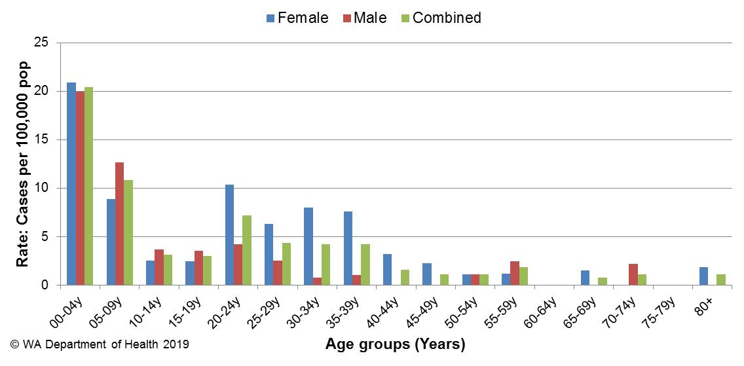

Figure 17 Age-specific notification rates for cryptosporidiosis by sex, WA, 2018

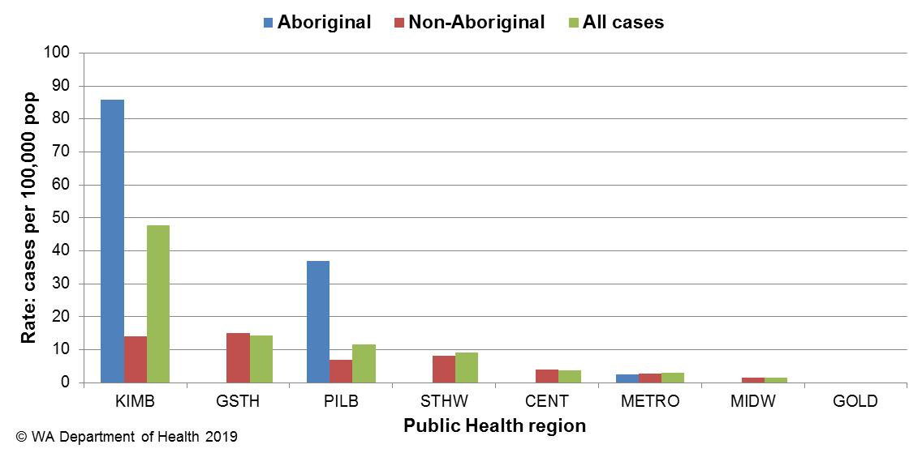

Figure 18 Cryptosporidiosis notification rates by region and Aboriginality, WA, 2018

### Shiga toxin-producing *E. coli* infection

There were 93 cases of STEC reported in 2018 with a rate of 3.4 cases per 100 000 population, which was 4.5 fold higher than the five year average. The large increase in 2018 compared to previous years is likely to be due to the introduction of PCR tests for STEC by two pathology laboratories, which also notified the most number of STEC cases (n=91). One of these laboratories uses a PCR test on bloody diarrhoea faecal specimens and began using this method in January 2016. Another laboratory also introduced a PCR test for STEC in July 2016, that is conducted when requested. Of the 93 cases, 83 were followed up and 67 (81%) had an acute illness prior to testing. Culture was performed on 75 specimens, 51 (68%) were culture-positive. Serotypes included O157:H7 (n=12), O26:H11 (n=8), O128:H2 (n=3) and two each of O103:H2, O111:H8 and O91:H14. Remaining isolates were all unique serotypes. Of the 93 cases, 45 (48%) were male and 48 (52%) were female with a median age of 31 years (range 0-90 years). Of those cases with an acute illness and with a known travel history, 44 (67%) had acquired their infection in WA and 22 (33%) had acquired their infection overseas. Overseas cases were predominantly from Indonesia (n=14), India (n=3) and South Africa (n=3), with one case each travelled to Vietnam and Myanmar. Of cases acquiring their illness in Australia, and with known onset, 10 (23%) had visited or lived in a rural area and 10 had contact with farm animals.

### *Vibrio parahaemolyticus* infection

There were 14 cases of *Vibrio parahaemolyticus* infection notified in 2018 with a rate of 0.5 cases per 100 000 population which was 19% lower than the mean rate of the previous five years (Appendix 1). These included seven male and seven female cases, ranging in age from 26 to 81 years. Of these cases, 11 reported travel overseas during their incubation period (Vietnam n=4, Indonesia n=3, Thailand n=2, Mauritius n=1, Tanzania n=1) and three acquired their illness in WA. Two locally acquired cases were investigated as part of a cluster (Section 5.3). Of the three locally acquired cases two were detected via stool samples and via a sputum sample.

### Hepatitis A infection

There were 12 cases of hepatitis A notified in 2018 with a rate of 0.4 cases per 100 000 population, which was a 35% decrease from the average rate of the previous five years (Appendix 1).

The age range for the 2018 cases was 4 to 54 years (median age 21 years), with seven (58%) male and five (42%) female notifications. The majority (n=7, 58%) of notifications in 2018 were acquired overseas (Figure 19), countries included India (n=2), Columbia (n=1), Pakistan (n=1), Somalia (n=1), South Africa (n=1) and Sudan (n=1).

Five cases were locally acquired, four were part of a national outbreak linked to the consumption of frozen pomegranate arils. The fifth local case had spent part of the incubation period interstate, with no high risk factors reported.

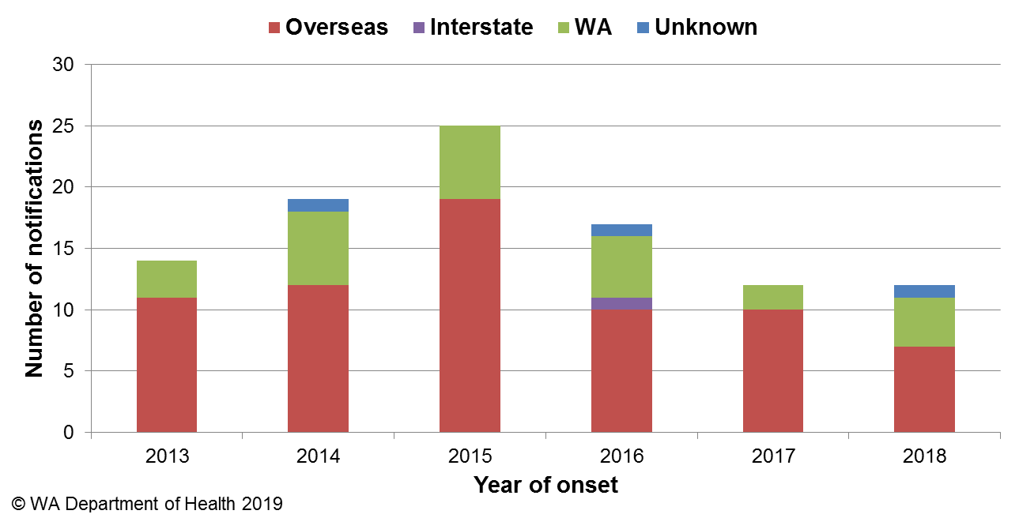

Figure 19 Place of acquisition for hepatitis A notifications, 2013 to 2018.

### *Yersinia* infection

There were 11 cases of culture-positive *Yersinia* *enterocolitica* infection notified in 2018, with a rate of 0.4 cases per 100 000 population, which is a 25% decrease compared to the mean rate of the previous five years (Appendix 1). There were five female and six male cases with ages ranging between 1 and 58 years. Four cases had acquired their illness in WA, two cases acquired their illness overseas in Indonesia (n=1) and Tanzania (n=1) and the place of acquisition was unknown for five cases. The majority (n=10) of cases were notified by one private pathology laboratory, which uses a faecal PCR screening test with reflex culture.

### Typhoid and paratyphoid fever

In 2018, there were 13 cases of typhoid fever (caused by *Salmonella* Typhi) notified with a rate of 0.5 cases per 100 000 population, which is similar to the average rate of the previous five years (Appendix 1). Twelve cases had recently travelled overseas prior to illness onset and countries included India (n=10), Bangladesh (n=1) and Zambia (n=1). The one case with no reported overseas travel was epidemiologically-linked to another confirmed case. Nine cases of paratyphoid fever were notified in 2018 with a rate of 0.3 cases per 100 000 population, which was 10% lower than the mean rate of the previous five years (Appendix 1). Eight paratyphoid fever cases were *S*. ParatyphiA and one case was *S*. Paratyphi B; all had overseas acquisition, and countries included India (n=5), Bangladesh (n=2), Indonesia (n=1) and Turkey (n=1).

### Listeriosis

There were eight cases of *Listeria monocytogenes* infection notified in 2018 with a rate of 0.3 cases per 100 000 population, which was 22% higher than the average rate of the previous five years (Appendix 1). All cases were non-pregnancy related and seven had immunocompromising illnesses. One case, aged 73 years, had minimal comorbidities. Cases ranged in age from 60 to 87 years, with seven male and one female case. No deaths were reported as a result of infection. Three locally acquired cases were investigated as part of a cluster (Section 5.3).

### Haemolytic Uraemic Syndrome (HUS)

One case of HUS was notified in 2018 in a female aged 42 years. The case was positive for STEC serotype O128:H2, but reported no diarrhoea. The main risk factor identified was consumption of an undercooked hamburger patty.

### Hepatitis E infection

There were two cases of hepatitis E notified in 2018. One case was male and one was female, aged 65 and 70 years, and cases had travelled to the United Kingdom (n=1) and Thailand and Europe (n=1).

### Cholera

There were no cases of cholera notified in WA in 2018.

### Botulism

There were no cases of botulism notified in WA in 2018.

# Gastrointestinal disease outbreaks and investigations

### Foodborne and probable foodborne outbreaks

There were 37 foodborne or probable foodborne gastroenteritis outbreaks investigated in WA in 2018 (Table 3). This was an almost 2 fold increase in foodborne and probable foodborne outbreaks compared to the five year average (n=20.2). The 37 foodborne outbreaks caused at least 343 cases of gastroenteritis and 57 hospitalisations. Short descriptions of these outbreaks are provided in [2018 quarterly reports](http://ww2.health.wa.gov.au/Articles/F_I/Infectious-disease-data/Enteric-infection-reports-and-publications-OzFoodNet).

**Aetiology**

Of the 37 outbreaks, 31 were due to STM, with 17 outbreaks of MLVA type 03-17-09-12-523, two outbreaks each of MLVA type 03-17-09-11-523 and MLVA type 03-11-15-10-523 and 10 outbreaks of unique MLVA types. This was an almost 3 fold increase in STM outbreaks compared to the five year average (n=13.2). For the remaining six outbreaks, two outbreaks were due to *Salmonella* Bovismorbificans and four were of unknown aetiology.

**Food vehicles**

The investigations of the 37 outbreaks identified food vehicles for 17 outbreaks. Of these, 12 (71%) were associated with eating egg dishes. This was a 1.5 fold increase in egg dishes compared to the five year average (n=8). Egg dishes included raw egg sauces, deep fried ice cream, raspberry mousse, chocolate molten lava cake, raw egg milkshake, beef casserole with lightly cooked eggs, Vietnamese pork roll and coleslaw which both contained a raw egg mayonnaise. All 12 egg-related outbreaks were caused by STM, including MLVA types 03-17-09-12-523 (n=8), and one each of 03-11-15-10-523, 04-18-16-11-523, 03-12-11-10-523 and an outbreak of multiple MLVA types with MLVA 03-13-11-10-523 and MLVA 3-13-13-10-523 identified in two cases each. The egg producer and production system was able to be determined in 11 of these 12 egg-related outbreaks and included multiple egg producers, and free-range and cage production systems. This information was gathered from environmental investigations. This finding should be interpreted with caution as denominator information regarding market share is unavailable, and multiple factors associated with the handling of eggs and egg-based products can contribute to whether an egg dish causes an infection.

**Epidemiological investigation and evidence**

The evidence that supported the classification of 37 enteric outbreaks as foodborne or probable foodborne transmission was obtained using only analytical studies for four outbreaks, analytical studies and microbiology for one outbreak, and only descriptive case studies (DCSs) for 32 outbreaks. The analytical studies involved interviewing those people who were at the implicated meal using a questionnaire on all foods/drinks available. These studies can be used to find a statistical association between a food eaten and illness, and in 2018 an association was found in five outbreaks. Microbiological evidence refers to the implicated food being positive for the same pathogen as the cases. For the outbreaks investigated as a DCS, there was strong circumstantial evidence to support probable foodborne transmission, such as independently visiting a common food business, or the venue being the only source of food for cases.

**Food preparation settings**

The setting where food was prepared for the 37 foodborne outbreaks in 2018 included 24 restaurants (caused by *S*. Typhimurium n=22, *S*. Bovismorbificans n=1, and unknown aetiology n=1), five private residences (all caused by *S*. Typhimurium), two aged care facilities (both outbreaks of unknown aetiology), two prisons (both caused by *S*. Typhimurium), two mine sites (one each caused by *S.* Typhimurium and *S*. Bovismorbificans), and one outbreak each in a college (*S.* Typhimurium) and a commercial caterer (unknown aetiology).

Table 3 Foodborne and probable foodborne outbreaks, 2018

|  |  |  |  |  |  |  |  |  |  |  |
| --- | --- | --- | --- | --- | --- | --- | --- | --- | --- | --- |
| **Mode of transmission** | **Outbreak code** | **Month of outbreak1** | **Where food prepared** | **Where food eaten** | **Agent responsible2** | **Number ill** | **Hospitalised** | **Died** | **Evidence3** | **Responsible vehicles** |
| probable foodborne | 042-2017-042 | Jan | private residence | private residence | Salmonella Typhimurium MLVA 03-17-09-12-523 | 3 | 3 | 0 | D | unknown |
| probable foodborne | 042-2018-001 | Jan | private residence | private residence | Salmonella Typhimurium MLVA 03-17-09-12-523 | 6 | 1 | 0 | D | unknown |
| probable foodborne | 042-2018-002 | Jan | restaurant | restaurant | Salmonella Typhimurium MLVA 03-17-10-12-523 | 5 | 2 | 0 | D | unknown |
| probable foodborne | 042-2018-003 | Feb | restaurant | restaurant | Salmonella Typhimurium MLVA 03-17-09-12-523 | 19 | 6 | 0 | D | egg dish: raw egg mayonnaise |
| probable foodborne | 042-2018-004 | Feb | restaurant | restaurant | Salmonella Typhimurium MLVA 03-17-09-12-523 | 21 | 5 | 0 | D | egg dish: egg dishes |
| probable foodborne | 042-2018-005 | Feb | restaurant | restaurant | Salmonella Typhimurium MLVA 03-17-09-12-523 | 3 | 0 | 0 | D | unknown |
| probable foodborne | 042-2018-006 | Mar | restaurant | restaurant | Salmonella Typhimurium MLVA 03-17-09-11-523 | 5 | 1 | 0 | D | unknown |
| probable foodborne | 042-2018-007 | Mar | private residence | private residence | Salmonella Typhimurium MLVA 03-17-09-12-523 | 3 | 0 | 0 | D | egg dish: beef casserole with lightly cooked eggs |
| probable foodborne | 042-2018-008 | Apr | restaurant | restaurant | Salmonella Typhimurium MLVA 03-26-17-12-523 | 11 | 3 | 0 | D | unknown |
| probable foodborne | 042-2018-009 | Apr | other | other | Salmonella Bovismorbificans | 5 | 1 | 0 | D | unknown |
| probable foodborne | 042-2018-010 | Apr | restaurant | restaurant | Salmonella Bovismorbificans | 2 | 2 | 0 | D | kebabs |
| probable foodborne | 042-2018-011 | Apr | restaurant | restaurant | Salmonella Typhimurium MLVA 03-17-09-12-523 | 5 | 1 | 0 | D | unknown |
| probable foodborne | 05/18/GRA | May | aged care | aged care | Unknown | 12 | 0 | 0 | D | unknown |
| probable foodborne | 05/18/MER | May | aged care | aged care | Unknown | 12 | 0 | 0 | D | unknown |
| probable foodborne | 042-2018-012 | May | other | other | Salmonella Typhimurium MLVA 03-17-09-12-523 | 2 | 0 | 0 | D | unknown |
| foodborne | 042-2018-013 | May | institution | institution | Salmonella Typhimurium MLVA 03-17-09-12-523 | 13 | 2 | 0 | A | egg dish: coleslaw with raw egg mayonnaise |
| foodborne | 042-2018-014 | May | restaurant | restaurant | Salmonella Typhimurium MLVA 03-17-09-12-523 | 19 | 6 | 0 | A | egg dish: hollandaise sauce |
| probable foodborne | 042-2018-015 | May | restaurant | restaurant | Salmonella Typhimurium MLVA 03-17-09-12-523 | 2 | 0 | 0 | D | unknown |
| probable foodborne | 042-2018-016 | May | restaurant | restaurant | Salmonella Typhimurium MLVA 03-17-09-12-523 | 10 | 2 | 0 | D | unknown |
| probable foodborne | 042-2018-017 | Jun | restaurant | restaurant | Salmonella Typhimurium MLVA 03-17-09-11-523 | 8 | 3 | 0 | D | unknown |
| foodborne | 042-2018-018 | Jun | restaurant | restaurant | Salmonella Typhimurium MLVA 03-17-09-12-523, MLST 19, SNP type SC-0050 | 7 | 0 | 0 | AM | egg dish: deep fried ice cream |
| probable foodborne | 042-2018-019 | Jun | restaurant | restaurant | Salmonella Typhimurium MLVA 03-12-11-10-523 | 3 | 2 | 0 | D | egg dish: chocolate molten lava cake |
| probable foodborne | 042-2018-020 | Jun | restaurant | restaurant | Salmonella Typhimurium MLVA 03-11-17-11-496 | 2 | 1 | 0 | D | Turkish smoked salmon sandwich |
| probable foodborne | 042-2018-021 | Jul | restaurant | restaurant | Salmonella Typhimurium MLVA 03-17-09-12-523 | 7 | 2 | 0 | D | egg dish: raspberry mousse |
| probable foodborne | 042-2018-022 | Jul | restaurant | restaurant | Salmonella Typhimurium MLVA 03-26-16-13-523 | 4 | 0 | 0 | D | unknown |
| probable foodborne | 042-2018-023 | Aug | restaurant | restaurant | Salmonella Typhimurium MLVA 03-13-11-10-523 x2; 03-13-13-10-523 x2 | 6 | 2 | 0 | D | egg dish: raw egg sauces |
| probable foodborne | 042-2018-024 | Aug | private residence | private residence | Salmonella Typhimurium MLVA 03-14-10-08-523 | 7 | 4 | 0 | D | unknown |
| probable foodborne | 042-2018-025 | Aug | private residence | private residence | Salmonella Typhimurium MLVA 03-25-18-11-523 | 4 | 0 | 0 | D | unknown |
| probable foodborne | 042-2018-026 | Sep | institution | institution | Salmonella Typhimurium MLVA 03-11-15-10-523 | 36 | 1 | 0 | D | unknown |
| probable foodborne | 042-2018-027 | Sep | restaurant | restaurant | Salmonella Typhimurium MLVA 03-17-09-12-523 | 3 | 0 | 0 | D | unknown |
| probable foodborne | 10-18-WPE | Oct | commercial caterer | other | unknown | 24 | 0 | 0 | A | sandwiches |
| probable foodborne | 11-18-MHP | Nov | restaurant | function | unknown | 19 | 0 | 0 | A | noodle Salad |
| probable foodborne | 042-2018-028 | Nov | institution | institution | Salmonella Typhimurium MLVA 03-11-15-10-523 | 11 | 1 | 0 | D | egg dish: raw egg milkshakes |
| probable foodborne | 042-2018-029 | Nov | restaurant | restaurant | Salmonella Typhimurium MLVA 04-18-16-11-523 | 10 | 2 | 0 | D | egg dish: aioli |
| probable foodborne | 042-2018-030 | Nov | restaurant | restaurant | Salmonella Typhimurium MLVA 03-17-11-12-523 | 3 | 0 | 0 | D | unknown |
| probable foodborne | 042-2018-031 | Dec | restaurant | restaurant | Salmonella Typhimurium MLVA 03-17-09-12-523 | 28 | 3 | 0 | D | egg dish: Vietnamese pork roll with raw egg mayonnaise |
| probable foodborne | 042-2018-032 | Dec | restaurant | restaurant | Salmonella Typhimurium MLVA 03-17-09-12-523 | 3 | 1 | 0 | D | Vietnamese pork roll |

**1**Month of outbreak is the month the outbreak was first reported or investigated, whichever is earliest

2MLVA=multi-locus variable number tandem repeat analysis, MLST = multi-locus sequence typing, SNP = single nucleotide polymorphisms

3D = descriptive, M= microbiological, A=Analytical

### Outbreaks due to non-foodborne transmission or with an unknown mode of transmission

In 2018, there were 104 outbreaks of gastroenteritis investigated that were not classified as foodborne disease outbreaks (Table 4). These outbreaks included 91 outbreaks associated with person-to-person transmission, 11 outbreaks where the mode of transmission was unclear or unknown and two outbreaks due to probable environmental transmission (Figure 20).

**Probable person-to-person outbreaks**

Of the 91 probable person-to-person (PTP) transmission outbreaks, 56 (62%) occurred in RCFs, 24 (26%) in child care centres, six in schools (7%), four (4%) in hospitals, and one (1%) at a minesite (Table 4). The causative agent for 39 (43%) of the outbreaks was confirmed as norovirus, one (1%) outbreak was due to rotavirus and adenovirus and one outbreak each for *Giardia*, adenovirus and sapovirus (1 % each). In the remaining 48 (53%) outbreaks the causative agent was unknown, either because a pathogen was not identified during testing, specimens were not collected, or viral testing was not requested. A total of 1825 people were affected by these outbreaks, with 30 hospitalisations and 7 associated deaths.

The number of PTP outbreaks in 2018 was 34% lower than the average of the previous five years (n=158).

**Outbreaks with unknown mode of transmission**

In the 11 outbreaks where the likely mode of transmission was unclear or unknown, nine (82%) occurred in aged care facilities, one was associated with a restaurant and one was reported in a hospital (Table 4).

There were five outbreaks where all cases had diarrhoea and the proportion of cases with vomiting ranged from 0-14%. These symptoms are not typical of norovirus outbreaks and therefore the outbreaks were described as unknown rather than person-to-person. Three out of five outbreaks had specimens tested which were negative for common bacterial and viral pathogens (including norovirus). No specimens were tested for one outbreak. One outbreak had one specimen positive for norovirus, in this outbreak all cases had diarrhoea only and the one case with the positive result had an onset and duration that did not match the other six cases that were all ill over one night only.

There were five outbreaks which were characterised with 5-33% vomiting and 67-96% diarrhoea, four were RCFs and one was a hospital. This percentage of vomiting was somewhat low for norovirus infection, and specimens were tested and were negative for routine pathogens and viruses (e.g. norovirus, rotavirus and adenovirus). One RCF outbreak had a specimen positive for *Clostridium perfringens* but as the isolate was toxin negative this was not attributed to foodborne transmission.

The restaurant outbreak had insufficient information to determine the mode of transmission.

**Probable environmental outbreaks**

There were two restaurant norovirus outbreaks in 2018 that were suspected to be caused by exposure to a contaminated environment.

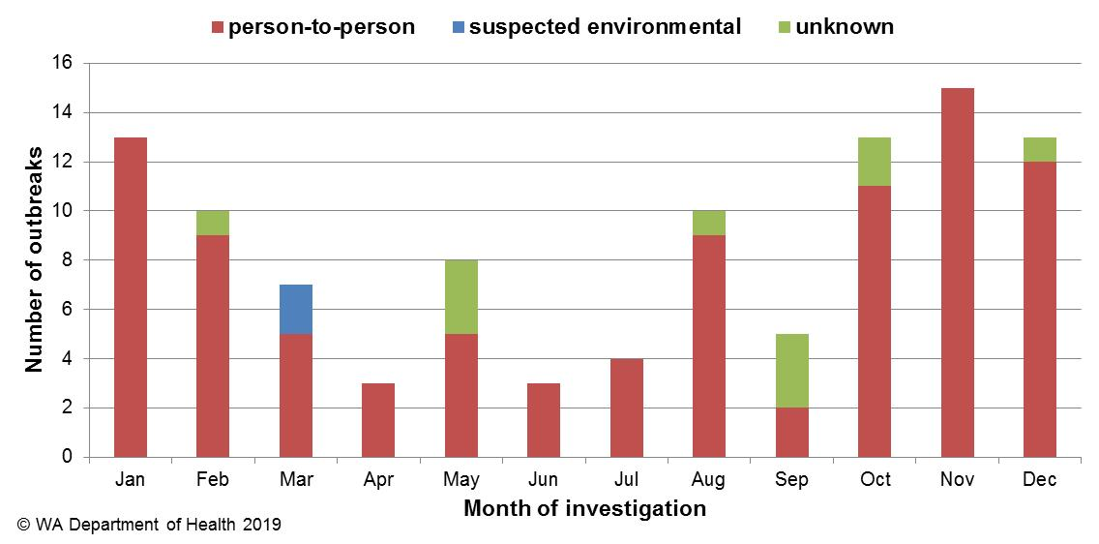

**Figure 20 Number of gastroenteritis outbreaks designated as non-foodborne transmission (person-to-person, suspected environmental, unknown) in 2018**

**Table 4 Outbreaks due to non-foodborne transmission or unknown mode of transmission in WA by setting and agent, 2018**



1Deaths temporally associated with gastroenteritis, but contribution to death not specified

### Cluster investigations

In 2018, there were 17 *Salmonella* clusters, two *Campylobacter* clusters and one cluster each of STEC, *Listeria*, *Cryptosporidium*, *Vibrio parahaemolyticus* and *Shigella* (Table 5) which are described in [2018 quarterly reports](http://ww2.health.wa.gov.au/Articles/F_I/Infectious-disease-data/Enteric-infection-reports-and-publications-OzFoodNet).

**Significant clusters  
*Salmonella* Typhimurium MLVA 03-17-09-12-523**

Up until September 2016, STM MLVA 03-17-09-12-523 had not been notified in WA since MLVA typing began in WA in January 2015. There were 78 cases of this MLVA type in 2016, starting with a single case in September, then 610 cases in 2017 and 421 cases in 2018 (Figure 21). In 2018, 105 cases were related to outbreaks and 17 point source outbreaks were investigated (Table 2). Of the 316 community cases, 273 were interviewed regarding exposures and comprised 51% males and 49% females, ranged in age from 0 to 96 years (median 28 years), and most (90%) resided in the Perth metropolitan area. Hospitalisation data was known for 311 community cases; 27% were hospitalised.

Eggs or egg-containing dishes were implicated in eight point source outbreaks of STM MLVA 03-17-09-12-523 in 2018. Three egg producers were implicated in two outbreaks each; these producers have been implicated in previous outbreaks of this MLVA type. In the remaining two outbreaks, one identified a forth egg producer however it was uncertain if these were the eggs used at the time of outbreak and the egg producer was unknown in the one outbreak.

A selection of isolates related to this ongoing investigation were further analysed by whole genome sequencing at ICPMR, NSW (See [OzFoodNet 2017 first quarter report](http://ww2.health.wa.gov.au/Articles/F_I/Infectious-disease-data/Enteric-infection-reports-and-publications-OzFoodNet) and OzFoodNet 2018 second quarter report). All were found to be closely related, which supported the hypothesis that illness is likely due to a common exposure or exposure to products with a common source of contamination.

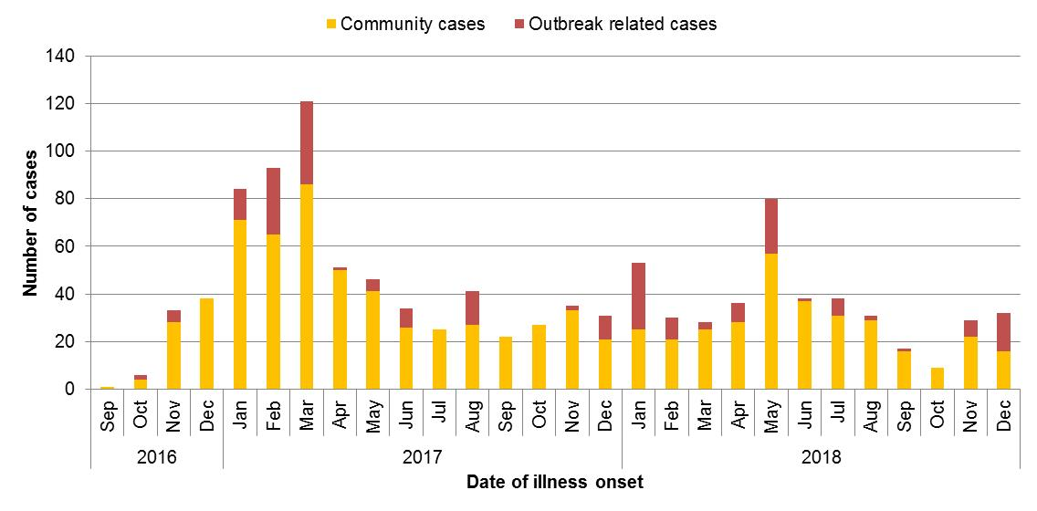

Figure 21 Notifications of *Salmonella* Typhimurium MLVA 03-17-09-12-523 in WA

From emergence of this strain in September 2016 to end of 2018, there have been 1109 cases in WA. This increase appears to be isolated to WA. A total of 35 point source outbreaks with this strain have been investigated, of which 17 were linked to consumption of raw or undercooked eggs. This is an ongoing investigation.

**Table 5 Cluster investigations in WA by month investigation started, setting and agent, 2018**

|  |  |  |  |  |  |
| --- | --- | --- | --- | --- | --- |
| **Month of outbreak** | **Setting exposed** | **Agent responsible\*** | **Number ill** | **Number hospitalised** | **Epidemiological study** |
| All Year | community | *Salmonella* Typhimurium MLVA 03-17-09-12-523 | 316 | 83 | Case series |
| Jan | community | STEC | 7 | 1 | Case series |
| Feb | community | *Listeria* | 3 | 3 | Case series |
| Feb | community | *Salmonella* Kentucky | 8 | 2 | Case series |
| Feb | community | *Salmonella* Muenchen | 6 | 2 | Case series |
| Feb | community | *Salmonella* Saintpaul | 21 | 3 | Case series |
| Feb | community | *Salmonella* Singapore | 10 | 1 | Case series |
| Mar | community | *Salmonella* Hvittingvoss | 6 | 4 | Case series |
| Apr | community | *Cryptosporidium* | 5 | 1 | Case series |
| Apr | community | *Salmonella* Typhimurium MLVA 03-18-09-12-523 | 3 | 1 | Case series |
| Apr | community | *Salmonella* Typhimurium MLVA 03-16-09-12-523 | 4 | 0 | Case series |
| May | community | *Vibrio parahaemolyticus* | 2 | 0 | Case series |
| Jun | community | *Salmonella* Havana | 3 | 1 | Case series |
| Jun | community | *Salmonella* Bovismorbificans | 3 | 0 | Case series |
| Aug | community | Campylobacter | 14 | 0 | Case series |
| Sept | community | Campylobacter | 19 | 0 | Case series |
| Oct | community | *Salmonella* Paratyphi B var Java | 2 | 1 | Case series |
| Oct | community | *Salmonella* Typhimurium MLVA 03-25/26-15-13-523 | 5 | 0 | Case series |
| Nov | community | *Shigella flexneri* 2B | 15 | 0 | Case series |
| Nov | community | *Salmonella* Typhimurium MLVA 03-13-15-10-523 | 4 | 0 | Case series |
| Dec | community | *Salmonella* Typhimurium MLVA 03-25-18-11-523 | 4 | 0 | Case series |
| Dec | community | *Salmonella* Typhimurium MLVA 03-17-09-11-523 | 6 | 0 | Case series |
| Dec | community | *Salmonella* Typhimurium MLVA 03-25-16-11-523 | 5 | 0 | Case series |
| Dec | community | *Salmonella* Typhimurium MLVA 03-13/14-11-10-523 | 9 | 2 | Case series |

*MLVA=multi-locus variable number tandem repeat analysis

# References

1. Hall G, Kirk MD, Becker N, Gregory JE, Unicomb L, Millard G, et al. Estimating foodborne gastroenteritis, Australia. Emerg Infect Dis 2005;11(8):1257-1264.
2. OzFoodNet Working Group. A health network to enhance the surveillance of foodborne diseases in Australia. Australian Government Department of Health 2017. <http://www.ozfoodnet.gov.au/>.
3. Western Australian Department of Health. A-Z list of case definitions. Western Australian Department of Health 2019. <http://ww2.health.wa.gov.au/Articles/N_R/Notification-of-infectious-diseases-and-related-conditions>.
4. Australian national notifiable diseases and case definitions. Australian Government Department of Health 2018

<http://www.health.gov.au/casedefinitions>

1. Western Australian Department of Health. Contact details for regional population / public health units. Western Australian Department of Health 2018. <http://healthywa.wa.gov.au/Articles/A_E/Contact-details-for-population-public-health-units>.
2. Dups JNB 2017, ‘Epidemiology and control of communicable diseases in Western Australia, 2015-2016’, Thesis (MPhil), Australian National University, viewed 6 December 2018, <https://openresearch-repository.anu.edu.au/handle/1885/133598>.

# Appendix 1: Number of notifications, notification rate2 and ratio of current to historical mean by pathogen/condition, 2013 to 2018, WA



1Abbreviations: STEC: Shiga toxin-producing *E. coli*; HUS: Haemolytic Uraemic Syndrome; NA: not applicable. 2Rate is cases per 100 000 population. 3Rotavirus was made notifiable in July 2006. 4Shigella only includes culture positive notifications.

© Department of Health 2019

This document can be made available in

alternative formats on request for a person

with a disability